Credit Name

2140

Credit Assignment

E11 Quadratic Equation

How has your program changed from planning to coding to now? Please explain?

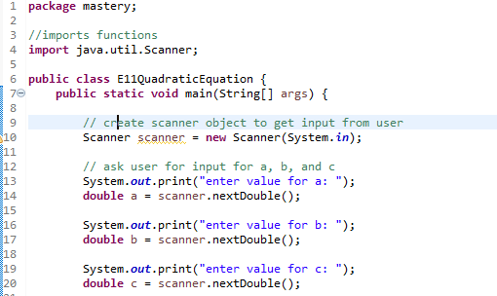

Starting with getting the values of a b and c

Calculating the discriminant

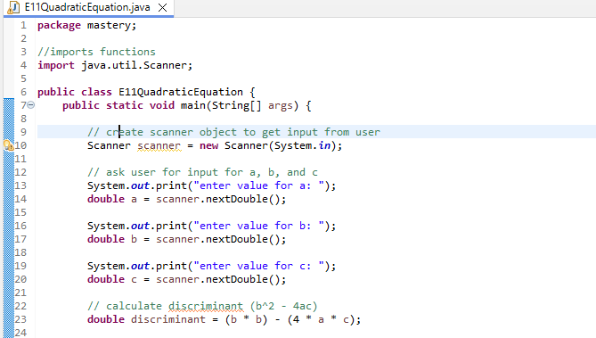

Checking if its positive negative or zero

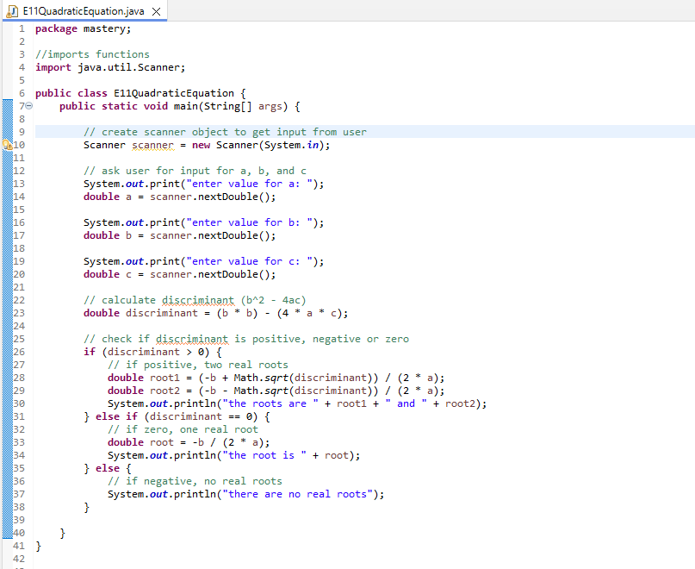

Fixing up little things like grammar punctuation ect

